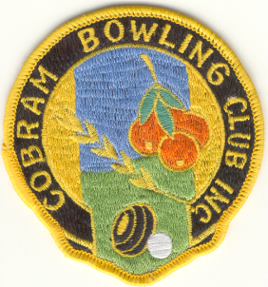
COBRAM BOWLING CLUB Inc.
Reg: No. A 13360 W 38-42 William Street, COBRAM. Phone: 5872 1510
ABN 60 315 532 414 P.O. Box 41, COBRAM. 3644. Fax : 5871 2704
Email: cobbowls@bigpond.com

PRESIDENT: SECRETARY:
Raymond Parks: 0427 040 821 Andrew Rushby: 0475 703 766
CIRCULAR TO ALL MEMBERS
Dear Member,
MEMBERSHIP SUBSCRIPTIONS ARE NOW DUE FOR SEASON 2021/2022.
As set at the Annual General Meeting 5th May 2021.
(Due in advance on 1st August 2021 and must be paid no later than 1st September 2021.)
FULL ($200.00) JUNIOR ($60.00) SOCIAL ($20.00)

Full and Junior Member subs includes entry fee for all eligible Club Championship Events.
Social Members may use the green for roll-up and are eligible to participate in Mufti events.
All Memberships are eligible for the Friday Night Members’ Draw.

PLEASE SEND SUBS and FORM TO P.O BOX 41 COBRAM 3644; OR HAND TO SECRETARY
OR PAY BY EFT TO BENDIGO BANK: BSB 633 000 ACCOUNT NO: 122490790 (use reference “name subs”).
-----------------------------------------------------------------------------
Please tear off and send with Subscription payment (or hand to Secretary).
(Required to update Membership database and Bowls Link records)

NAME :__________________________________________________( Date of Birth) ______________

ADDRESS: _________________________________________________________________________

PHONE NO: (Home) _________________ (Bus.)__________________ (Mobile) _________________

EMAIL ADDRESS: _______________________________________________________________

PLEASE CIRCLE ONE: - FULL ($200.00)* JUNIOR ($60.00) SOCIAL ($20.00)
PAID BY: (please circle) Cash/cheque enclosed EFT (Date …/…/20….)
*Please note if you require a payment plan, contact the President or Treasurer.
The ongoing support from volunteer Members is always greatly appreciated. If you are able to assist in any of the areas listed below, please indicate with a tick.
AREAS | Wish to help (tick).
Assisting Greenkeeper
Gardens / Grounds
Cleaning
Bar Duties
Other (please describe)
Regards,
Signature………………………… Andrew Rushby
Secretary

Office use only: Rec. No..............................................Date.................................Sig…………………............

